Name: ____________________________
Cherokee Virtual Scavenger Hunt
Website: https://www.smore.com/sem0h-the-trail-of-tears
1. Read the Indian Removal Act. Who signed the act into a law: _________________________________
2. Scroll down to view the Indian Removal Map. List the names of all the Indian Tribes listed in the legend:
__________________________________
__________________________________
__________________________________
__________________________________
__________________________________
3. Scroll down and read the Trail of Tears passage and list the states that the Cherokee’s lived in:
__________________________________
__________________________________
__________________________________
__________________________________
__________________________________
4. What river did they have to cross to get to Indian Territory? _____________________
Select the Trail of Tears Facts and Information For Kids Link and answer the following questions:
5. How many miles roughly did the Indians travel on the Trail of Tears? ______________
6. About how many Cherokee Indians were removed by the US Army? _______________________
7. About how many total Indians were removed in the act? ______________________.
8. What does “Nunahi-Duna-Dlo-Hilu-I” mean? __________________________
Go back to the Trail of Tears original website and add the dates to the timeline below.
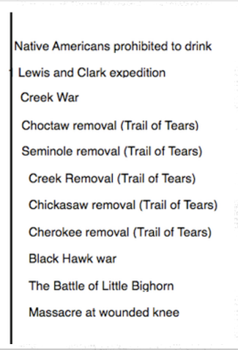

9. About how many years spanned between the Choctaw removal and the Cherokee removal? _________________________
10. Which Native American group was removed first? ____________________________
11. Watch the Trail of Tears video with the highlighted map.
12. Who wrote, Only the Names Remain? ___________________________________
13. Read the Treaty of Echota and list what it did. _______________________________ ________________________________________________________________________________________________________________________________________________

14. Select the picture Native Traditions Artwork Choctaw Trail of tears and list what you see in the picture. ________________________________________________________________________________________________________________________________________________
15. Watch the Trail of Tears animation video.
16. Study the map and Trail of Tears site markers in Alabama, Tennessee, and Georgia.
17. What is the first sentence in the Alabama-Tennessee picture?
________________________________________________________________________________________________________________________________________________
18. Watch the Story of Us-Trail of Tears video.
19. What is the Cherokee Rose? _________________________________________
Draw a small picture of it in the box.

20. Click the ushistory.org link and list what Sequoyah did that was important for the Cherokee. _____________________________________
21. Go back to the original site and watch the Trail of Tears Short Documentary.
22. Go the classcompass.weebly.com and find the blog page. Once you have found that page write a short blog (at least a paragraph) answering the blog question. Put your first name only on the page so that I know who wrote it. Then respond to at least three of your classmates blog.
The End

